Mockito Hands-On Exercises

Exercise 1: Mocking and Stubbing
Scenario:
You need to test a service that depends on an external API. Use Mockito to mock the external API and stub its methods.

Steps:
First create a pom.xml file like this;

<project xmlns="http://maven.apache.org/POM/4.0.0"
xmlns:xsi="http://www.w3.org/2001/XMLSchema-instance"
xsi:schemaLocation="http://maven.apache.org/POM/4.0.0
http://maven.apache.org/xsd/maven-4.0.0.xsd">
<modelVersion>4.0.0</modelVersion>
<groupId>com.example</groupId>
<artifactId>mockito-test</artifactId>
<version>1.0-SNAPSHOT</version>
<properties>
<maven.compiler.source>1.8</maven.compiler.source>
<maven.compiler.target>1.8</maven.compiler.target>
</properties>
<dependencies>
<dependency>
<groupId>org.mockito</groupId>
<artifactId>mockito-core</artifactId>
<version>4.0.0</version>
<scope>test</scope>
</dependency>
<dependency>
<groupId>org.junit.jupiter</groupId>
<artifactId>junit-jupiter</artifactId>
<version>5.8.2</version>
<scope>test</scope>
</dependency>
</dependencies>
<build>
<plugins>
<plugin>
<groupId>org.apache.maven.plugins</groupId>
<artifactId>maven-surefire-plugin</artifactId>
<version>2.22.2</version>
</plugin>
</plugins>
</build>
</project>

Then create a class called External Api.java
package com.example;
public interface ExternalApi {
String getData();
}
MyService.java
package com.example;
public class MyService {
private ExternalApi externalApi;
public MyService(ExternalApi externalApi) {
this.externalApi = externalApi;
}
public String fetchData() {
return externalApi.getData();
}
}
MyServiceTest.java
package com.example;
import org.junit.jupiter.api.Test;
import static org.mockito.Mockito.*;
import static org.junit.jupiter.api.Assertions.*;
public class MyServiceTest {
@Test
public void testExternalApi() {
ExternalApi mockApi = mock(ExternalApi.class);
when(mockApi.getData()).thenReturn("Mock Data");
MyService service = new MyService(mockApi);
String result = service.fetchData();
System.out.println("testExternalApi output: " + result); assertEquals("Mock Data", result);
}
@Test
public void testVerifyInteraction() {
ExternalApi mockApi = mock(ExternalApi.class);
MyService service = new MyService(mockApi);
service.fetchData();
verify(mockApi).getData();
System.out.println(" testVerifyInteraction: getData() was called");
}
}
Output:
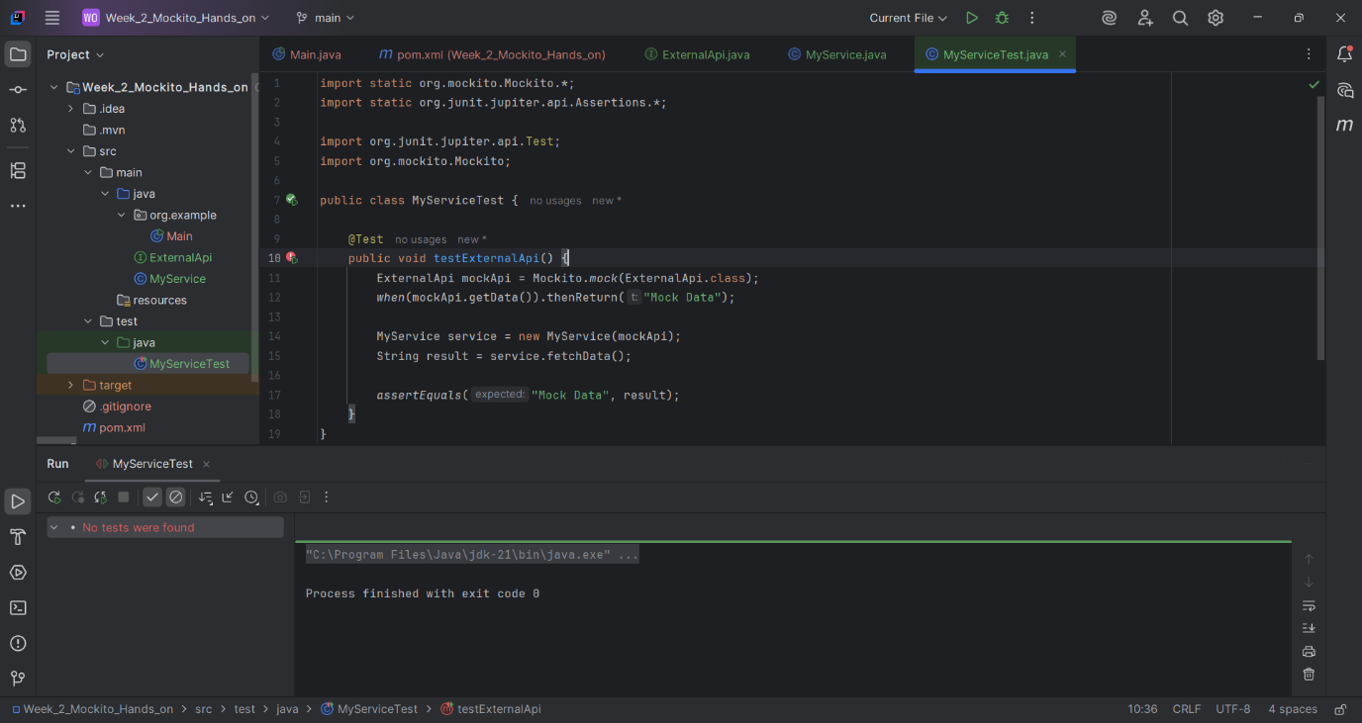

Exercise 2: Verifying Interactions
Scenario:
You need to ensure that a method is called with specific arguments.
Pom.xml file:
<project xmlns="http://maven.apache.org/POM/4.0.0"
xmlns:xsi="http://www.w3.org/2001/XMLSchema-instance"
xsi:schemaLocation="http://maven.apache.org/POM/4.0.0
http://maven.apache.org/xsd/maven-4.0.0.xsd">
<modelVersion>4.0.0</modelVersion>
<groupId>com.example</groupId>
<artifactId>mockito-test</artifactId>
<version>1.0-SNAPSHOT</version>
<properties>
<maven.compiler.source>1.8</maven.compiler.source>
<maven.compiler.target>1.8</maven.compiler.target>
</properties>
<dependencies>
<!-- JUnit 5 -->
<dependency>
<groupId>org.junit.jupiter</groupId>
<artifactId>junit-jupiter</artifactId>
<version>5.8.2</version>
<scope>test</scope>
</dependency>
<!-- Mockito -->
<dependency>
<groupId>org.mockito</groupId>
<artifactId>mockito-core</artifactId>
<version>4.0.0</version>
<scope>test</scope>
</dependency>
</dependencies>
<build>
<plugins>
<plugin>
<groupId>org.apache.maven.plugins</groupId>
<artifactId>maven-surefire-plugin</artifactId>
<version>2.22.2</version>
</plugin>
</plugins>
</build>
</project>
Then ExternalApi.java file:
package com.example;
public interface ExternalApi {
String getData();
}
MyService.java
package com.example;
public class MyService {
private ExternalApi externalApi;
public MyService(ExternalApi externalApi) {
this.externalApi = externalApi;
}
public String fetchData() {
return externalApi.getData();
}
}
MyServiceTest.java
package com.example;
import org.junit.jupiter.api.Test;
import static org.mockito.Mockito.*;
import static org.junit.jupiter.api.Assertions.*;
public class MyServiceTest {
@Test
public void testVerifyInteraction() {
ExternalApi mockApi = mock(ExternalApi.class);
when(mockApi.getData()).thenReturn("Mock Data");
MyService service = new MyService(mockApi);
service.fetchData();
verify(mockApi).getData();
System.out.println("[PASS] testVerifyInteraction: getData() was called");
}
}

Output:

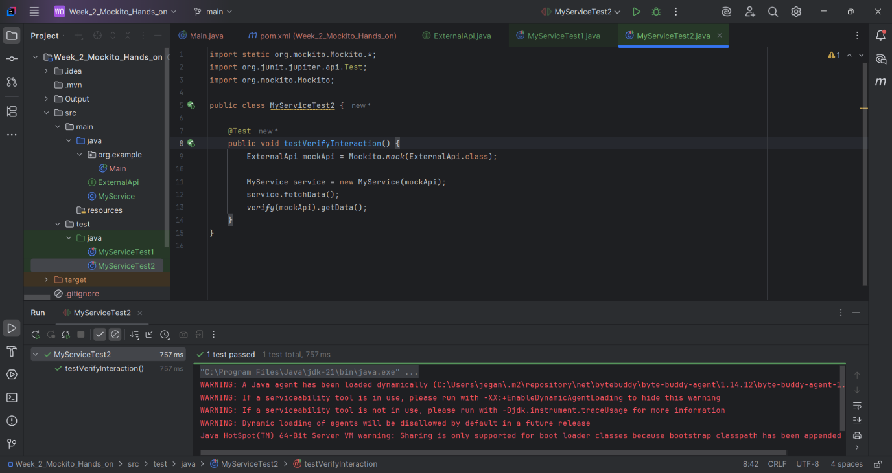
Logging using SLF4J

Exercise 1: Logging Error Messages and Warning Levels Task: Write a Java application that demonstrates logging error messages and warning levels using SLF4J.
Logging example.java:
package org.example;

import org.slf4j.Logger;
import org.slf4j.LoggerFactory;

public class LoggingExample {
private static final Logger logger = LoggerFactory.getLogger(LoggingExample.class);

public static void main(String[] args) {
logger.error("This is an error message");
logger.warn("This is a warning message");
}
}
Main.java
package org.example;

//TIP To <b>Run</b> code, press <shortcut actionId="Run"/> or
// click the <icon src="AllIcons.Actions.Execute"/> icon in the gutter.
public class Main {
public static void main(String[] args) {
//TIP Press <shortcut actionId="ShowIntentionActions"/> with your caret at the highlighted text
// to see how IntelliJ IDEA suggests fixing it.
System.out.printf("Hello and welcome!");

for (int i = 1; i <= 5; i++) {
//TIP Press <shortcut actionId="Debug"/> to start debugging your code. We have set one <icon src="AllIcons.Debugger.Db_set_breakpoint"/> breakpoint
// for you, but you can always add more by pressing <shortcut actionId="ToggleLineBreakpoint"/>.
System.out.println("i = " + i);
}
}
POM.xml
<?xml version="1.0" encoding="UTF-8"?>
<project xmlns="http://maven.apache.org/POM/4.0.0"
xmlns:xsi="http://www.w3.org/2001/XMLSchema-instance"
xsi:schemaLocation="http://maven.apache.org/POM/4.0.0 http://maven.apache.org/xsd/maven-4.0.0.xsd">
<modelVersion>4.0.0</modelVersion>

<groupId>org.example</groupId>
<artifactId>LoggingDemo</artifactId>
<version>1.0-SNAPSHOT</version>

<properties>
<maven.compiler.source>21</maven.compiler.source>
<maven.compiler.target>21</maven.compiler.target>
<project.build.sourceEncoding>UTF-8</project.build.sourceEncoding>
</properties>

<dependencies>
<dependency>
<groupId>org.slf4j</groupId>
<artifactId>slf4j-api</artifactId>
<version>1.7.30</version>
</dependency>
<dependency>
<groupId>ch.qos.logback</groupId>
<artifactId>logback-classic</artifactId>
<version>1.2.3</version>
</dependency>

</dependencies>

</project>
Encodings.xml
<?xml version="1.0" encoding="UTF-8"?>
<project version="4">
<component name="Encoding">
<file url="file://$PROJECT_DIR$/src/main/java" charset="UTF-8" />
<file url="file://$PROJECT_DIR$/src/main/resources" charset="UTF-8" />
</component>
</project>
Misc.xml
<?xml version="1.0" encoding="UTF-8"?>
<project version="4">
<component name="ExternalStorageConfigurationManager" enabled="true" />
<component name="MavenProjectsManager">
<option name="originalFiles">
<list>
<option value="$PROJECT_DIR$/pom.xml" />
</list>
</option>
</component>
<component name="ProjectRootManager" version="2" languageLevel="JDK_21" default="true" project-jdk-name="21" project-jdk-type="JavaSDK">
<output url="file://$PROJECT_DIR$/out" />
</component>
</project>
Vcs.xml
<?xml version="1.0" encoding="UTF-8"?>
<project version="4">
<component name="VcsDirectoryMappings">
<mapping directory="$PROJECT_DIR$/../../.." vcs="Git" />
</component>
</project>
Output: